Mechanical Overview

Year: 2023 Semester: Fall Team: 5 Project: Smart Air Hockey Table

Creation Date: September 18, 2023 Last Modified: September 23, 2023

Author: Trevor Moorman Email: tmoorma@purdue.edu

* 1. Commercial Product Packaging
  2. Product #1

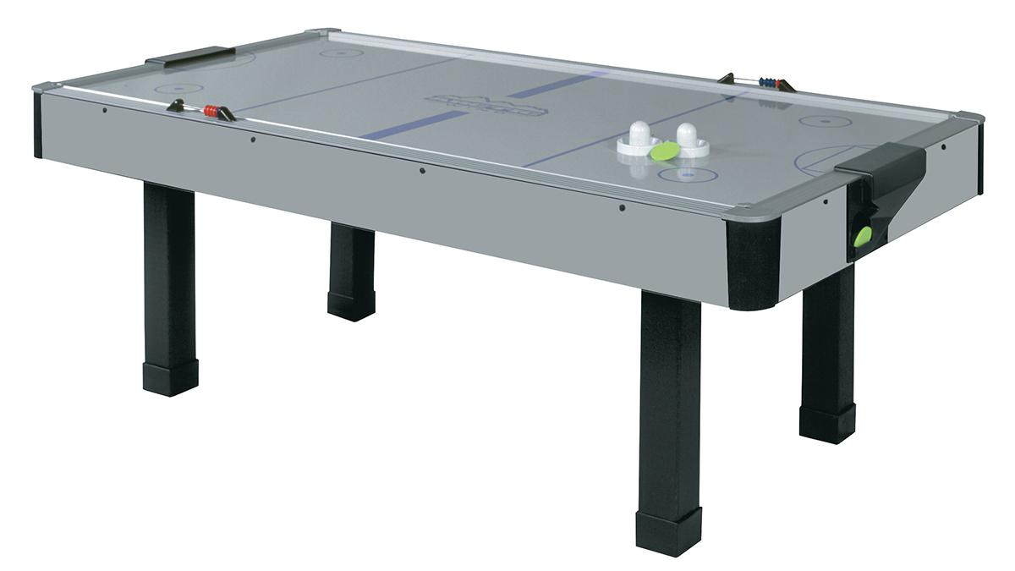

*Figure 1: Dynamo Arctic Wind*

The Dynamo Arctic Wind [1] is the prime example of a minimalistic, quality air hockey table built for residential use. The 7-foot Arctic Wind’s overall dimensions are 209.55 cm long, 107.95 cm wide, and 76.2 cm tall [2]. The sides of the table consist of either plain gray or oak branded laminate. The muted visuals are designed to prevent the table from clashing with the decor surrounding the table, given that the Arctic Wind is marketed as a residential air hockey table. Since our project is also being built for residential use, our project will similarly lack complex designs.

The playing surface’s dimensions are 198.12 cm long and 96.52 cm wide [2] and consists of a medium density fiberboard coated with laminate. The playing surface’s laminate has been dyed to mimic a hockey rink, which includes the center line, zone lines, face off circles, and goal crease. The center line is the only marking which holds gameplay significance as it delineates where each player can strike the puck. Therefore, the other markings on the playing surface serve to enhance the appearance of the surface by breaking up the plain white.

An aluminum rail surrounds the playing surface which serves several purposes. First, the aluminum rail reinforces the sides of the table and protects it from frequent, high-speed collisions with the puck. Second, the aluminum rail ensures accurate puck deflection [1]. While the table is not designed for professional use, air hockey as a game is inherently competitive. Therefore, accurate puck deflection ensures that the game is fair to both players which makes the game more enjoyable. Finally, the aluminum rail causes a ping when the puck collides with it, which many air hockey players describe as satisfying. While a minor effect when compared to the first two purposes described, this positive audio feedback is especially important for the Arctic Wind given that it lacks the ability to generate audio like more advanced air hockey tables.

The Arctic Wind’s scoring system is extremely minimalistic. A plastic goal consisting of a slot in the railing feeding into a funnel is in the middle of both short sides of the table. A player scores when the puck enters the slot, and manually tracks the point by moving one of the scoring beads on the abacus closest to them. The player that has been scored on then retrieves the puck from the output of the goal’s funnel on the outside edge of the table. The goal must be strong enough to withstand the puck forcefully striking the back of the goal before falling through the funnel. The shape of the funnel must ensure that the puck can not get stuck, as it would be extremely difficult for the player to retrieve the puck in such a state.

Overall, the packaging of the Dynamo Arctic Wind is exceedingly simple while maintaining all the core functionality required for air hockey. The understated design will be attractive to some consumers as it reduces the amount of space the table is perceived to take up within a household. However, the understated design will be repulsive to other customers who want an eye-catching design to match the significant amount of money and space dedicated to this product within their home.

* 1. Product #2

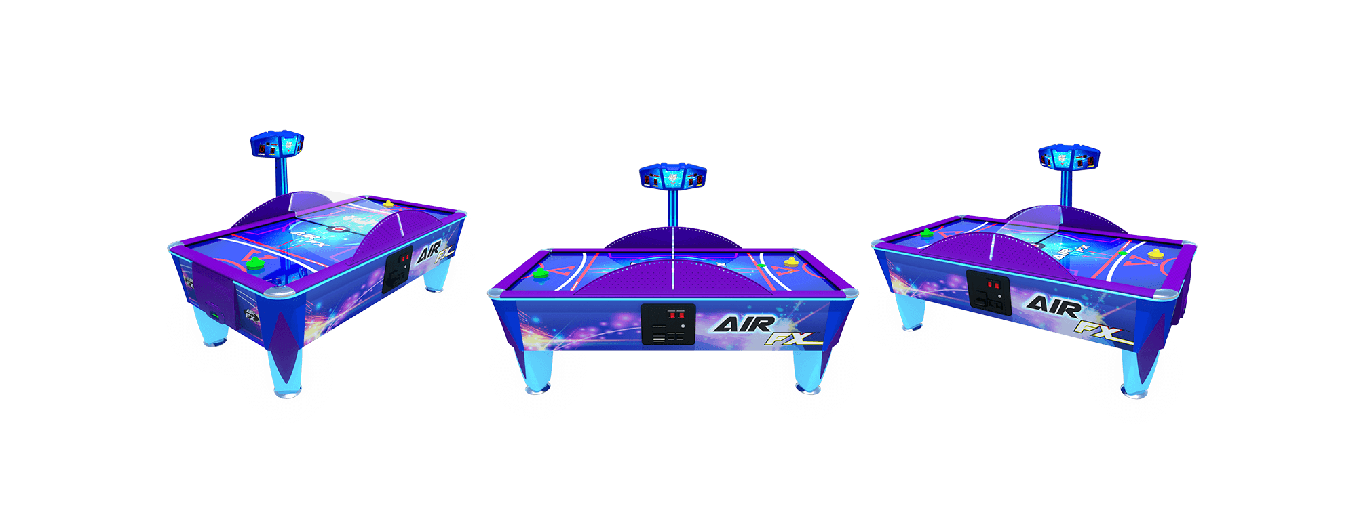

*Figure 2: ICE Air FX*

In contrast to the Dynamo Arctic Wind, the ICE Air FX [3] features a complex and striking package to fit its commercial use case. The most apparent difference with the ICE Air FX is its size. The Air FX’s overall dimensions are 236.2 cm long, 157.5 cm wide, and 124.5 cm tall [3]. The larger dimensions serve two major purposes. First, the larger dimensions provide the table with greater stability and durability, which is necessary to withstand its harsh commercial environment. Our design will not replicate the large dimensions of the Air FX. Since our project is being designed for residential use, improved stability and durability are not required. Therefore, the additional material required to increase the table’s dimensions will only increase the project’s cost and increase the difficulty of moving the table. Second, the product’s larger package improves the likelihood it will attract attention. Given that the ICE Air FX is expected to generate income by convincing people to pay to use it, more attention is better. In addition to the larger dimensions, the Air FX is covered in graphics on all sides. The graphics serve to further grab the attention of those around it and entice them to play. The vibrant colors of the designs naturally draw attention. The backlit playing field and multi-color LED lighting further amplify this effect [3]. The Air FX can even be customized with alternate graphics to better cater to its intended audience [3]. While our project is not expected to be used commercially to generate revenue, creating attractive packaging will improve its likelihood to be purchased. Our project will utilize a transparent playing surface to best leverage the LEDs beneath. The LEDs generate visual interest in our project while it is in use while allowing the packaging to otherwise remain plain to better fit in household settings.

The ICE Air FX features an acrylic divider above the center of the table perpendicular to the players and flanked by supporting short aluminum walls. These two features are necessary to account for the aggressive gameplay anticipated. In the event that the puck becomes airborne, the opposing player and any potential bystanders are protected by these barriers. Besides protecting the players and bystanders, these barriers protect the business that owns the table from potential legal issues. These barriers are not required for the anticipated use of our project. Therefore, similarly to the downsides with the larger dimensions, these barriers would primarily increase the cost and weight of our project.

A scoreboard stands at the center of one of the long sides of the table, above the aluminum barrier. The scoreboard’s location allows either of the players to quickly glance and determine their score by only momentarily moving their eyes. Easy access is integral given the high-speed nature of air hockey. This is a significant improvement compared to the Dynamo Arctic Wind as the user could not glance to determine the score using its abacus method.

On the long side opposite the scoreboard, there is a panel below the playing field. This panel serves two main purposes. First, this panel allows players to pay to play and receive tickets should the owner decide to implement either system. By providing an interface common to other arcade machines, the ICE Air FX leverages prior knowledge that consumers will understand its intent and purpose. Second, the panel provides easy access to most of the table’s electronics, which allows for easy maintenance of common issues. This reduces the amount of time the table spends disabled while waiting for maintenance, thus improving the table’s overall profitability.

Overall, the ICE Air FX has a large and complex packaging that is needed to fit the demanding requirements of its commercial environment. At best, when used in a residential setting, these features are minor improvements, such as increased durability. At worst, when used in a residential setting, these features are detrimental to the overall design of the table. For example, the increased size of the table decreases the ease at which the table can be moved and increases the amount of valuable space it takes up within a home.

2.0 Project Packaging Description

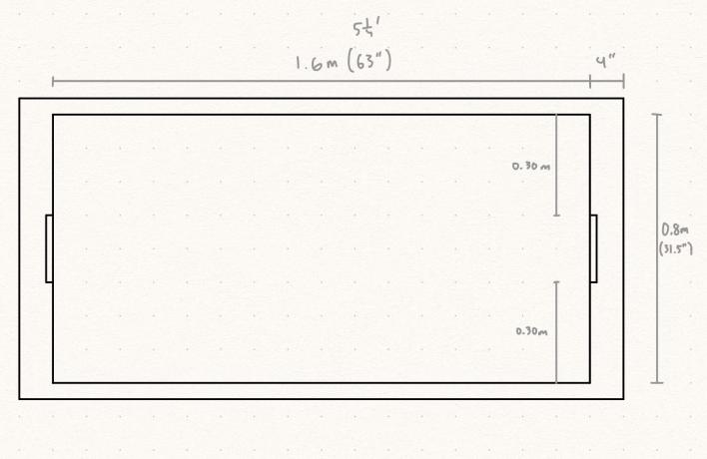

*Figure 3: Sketch of Packaging’s Top View*

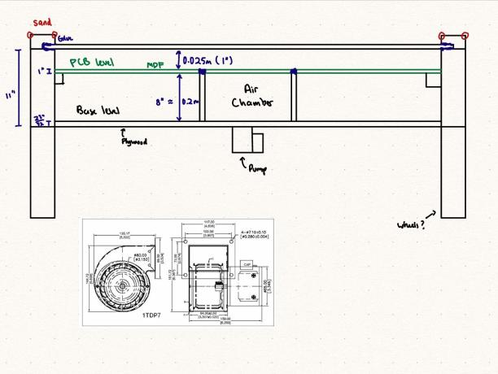

*Figure 4: Sketch of Packaging’s Side View Cross Section*

Our project’s packaging seeks to combine the best traits of the Dynamo Arctic Wind and the ICE Air FX to best fit the residential use case of our innovative air hockey table. Figures 3 and 4 above show how similar the shape of the project’s packaging is to the Dynamo Arctic Wind with a slight size decrease. The most notable differences in the Smart Air Hockey Table’s packaging are the deeper chamber beneath the playing field and the table’s legs being moved to the outer edge.

Similar to the Dynamo Arctic Wind, the Smart Air Hockey Table will feature a plain exterior. The Smart Air Hockey’s exterior will be painted a single color with some simple branding. The muted design of the exterior will help the Smart Air Hockey Table fit with the existing decor of the household, rather than constantly demanding attention like the ICE Air FX. However, the transparent playing surface will allow the LEDs beneath to enhance the visual appeal of the Smart Air Hockey Table while in use. Figure 5 of appendix 1 showcases how the Smart Air Hockey Table’s 512 LEDs will be distributed across the surface. While figure 5 of appendix 1 and figure 10 of appendix 3 both represent the sensor PCBs as green for clarity, the project will feature white sensor PCBs. The white PCBs better reflect the color of the LEDs across the playing field. Furthermore, allowing the user to view the electrical components within the table provides the project with a technological appearance which bolsters the Smart Air Hockey Table’s overall innovative feel. Thus, the project’s packaging combines the simplicity of the Dynamo Arctic Wind while not in use with the visual appeal of the ICE Air FX while in use.

Taking inspiration from the ICE Air FX’s digital display, the Smart Air Hockey Table will feature an OLED display embedded into the table on the player’s left from the goal. With this positioning, the player can quickly glance at the current score during gameplay. By embedding the OLED into the table rather than building a central scoreboard above the table, the Smart Air Hockey Table retains the sleek shape of the Dynamo Arctic Wind. Furthermore, the inclusion of a scoreboard above the table could interrupt the consumer’s sight line which would limit where the Smart Air Hockey Table could be positioned within a home.

When combined, the simple design of the Smart Air Hockey Table reduces its overall cost. The project’s electrical components already incur a significant cost. By minimizing the cost of the project’s packaging, the Smart Air Hockey Table maintains a reasonable price point for residential consumers. Even with this simplistic design, the team currently estimates the packaging will cost $265.71 to construct, as stated in table 1 of appendix 2.

3.0 Sources Cited

[1] Valley Dynamo. *Dynamo Arctic Wind* [Online]. Available: <https://valley-dynamo.com/shop/arctic-wind/> (Accessed September 22, 2023)

[2] The Shuffleboard Federation. *Dynamo Arctic Wind Air Hockey Table* [Online]. Available: <https://www.shuffleboardfederation.com/dynamo-artic-wind-air-hockey-table.html> (Accessed September 22, 2023)

[3] ICE. *ICE Air Fx* [Online]. Available: <https://www.icegame.com/category/1447/air-fx-air-hockey> (Accessed September 22, 2023)

[4] The Home Depot. *23/32 in. x 4 ft. x 8 ft. BC Sanded Pine Plywood* [Online]. Available: <https://www.homedepot.com/p/23-32-in-x-4-ft-x-8-ft-BC-Sanded-Pine-Plywood-201428/100061386> (Accessed September 22, 2023)

[5] The Home Depot. *3/4 in. x 4 ft. x 8 ft. MDF Panel* [Online]. Available: <https://www.homedepot.com/p/3-4-in-x-4-ft-x-8-ft-MDF-Panel-D11612490970000/304325742> (Accessed September 22, 2023)

[6] The Home Depot. *36 in. x 72 in. x 0.125 in. Thick Acrylic Non-Glare, Matte P95 Sheet* [Online]. Available: <https://www.homedepot.com/p/Falken-Design-36-in-x-72-in-x-0-125-in-Thick-Acrylic-Non-Glare-Matte-P95-Sheet-Falken-Design-ACRYLIC-P95-1-8-3672/308669657> (Accessed September 22, 2023)

[7] MellowPine. *How Much Does a Sheet of Plywood Weigh? Charts* [Online]. Available: <https://mellowpine.com/blog/how-much-does-a-sheet-of-plywood-weigh/> (Accessed September 22, 2023)

[8] Bell Forest Products. *Average Dry Weight* [Online]. Available: <https://www.bellforestproducts.com/info/popups/average-dry-weight/> (Accessed September 22, 2023)

[9] Micro Center. *Inland 1.75mm PETG 3D Printer Filament 1kg Plastic Spool (2.2 lbs) - Black* [Online]. Available: <https://www.microcenter.com/product/503745/inland-175mm-petg-3d-printer-filament-1kg-plastic-spool-(22-lbs)-black?sp=714> (Accessed September 22, 2023)

Appendix 1: CAD Model Illustrations

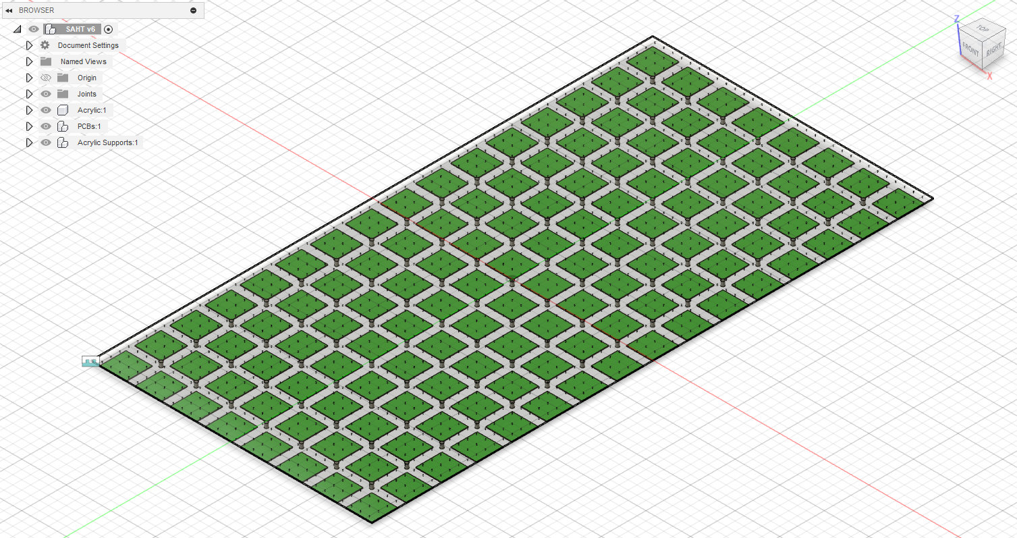

Figure 5: CAD model showing the layout of the sensor PCBs under the acrylic playing field

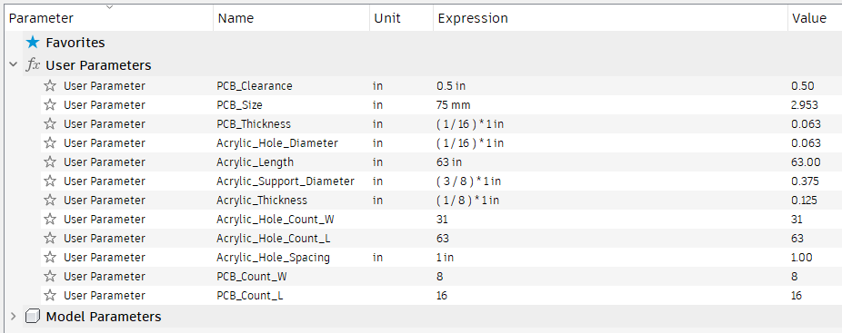

Figure 6: User parameters used to generate the CAD model in figure 5Appendix 2: Project Packaging Specifications

|  |  |  |  |
| --- | --- | --- | --- |
| Material | Quantity | Weight (g) | Cost |
| 23/32 in. x 4 ft. x 8 ft. BC Sanded Pine Plywood [4] | 1 | ~26,300 [7] | $45.28 |
| 3/4 in. x 4 ft. x 8 ft. MDF Panel [5] | 1 | ~45,350 [7] | $58.44 |
| 36 in. x 72 in. x 0.125 in. Thick Acrylic Non-Glare, Matte P95 Sheet [6] | 1 | 5,960 | $143.00 |
| BIDC Wood Planks | ~243,000 cm3 | ~136,250 [8] | Free (Available at BIDC) |
| 3D Filament: Inland PETG [9] | 1 | 1,000 | $18.99 |
| Screws | ~25 | ~450 | Free (Available at BIDC and Senior Design Lab) |
| Bolts | ~20 | ~185 | Free (Available at BIDC and Senior Design Lab) |
| Nuts | ~20 | ~80 | Free (Available at BIDC and Senior Design Lab) |
| Washers | ~20 | ~48 | Free (Available at BIDC and Senior Design Lab) |
| Estimated Total | | 215,623 | $265.71 |

Table 1: Materials List

|  |  |
| --- | --- |
| Tooling | Availability |
| 3D Printer: Original Prusa i3 MK2.5S | Owned by Benjamin Owen |
| CNC Machine | BIDC |
| Laser Engraver and Cutter: Trotec Speedy 400 Flexx | BIDC |
| Drill | BIDC, Senior Design Lab |
| Hammer | BIDC, Senior Design Lab |
| Screwdriver | BIDC, Senior Design Lab |

Table 2: Tooling Requirements

Appendix 3: PCB Footprint Layout

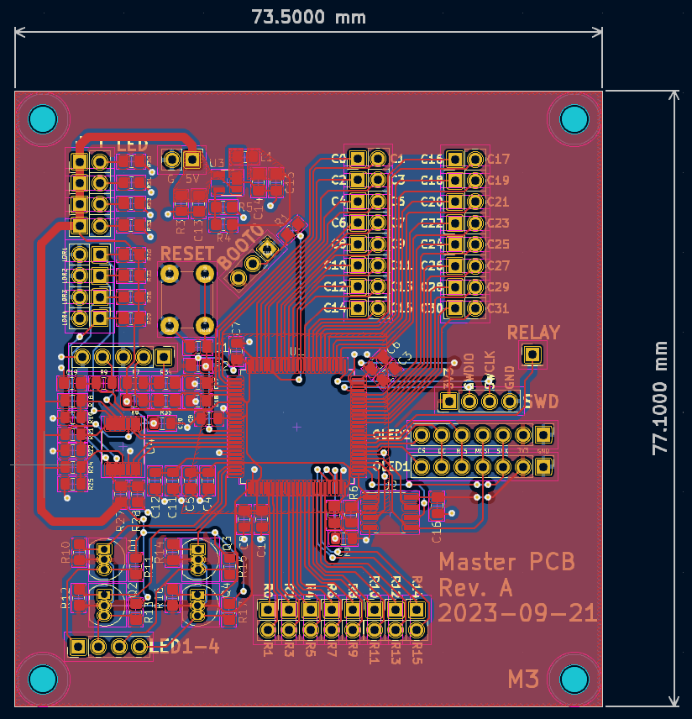

Figure 7: Master PCB design

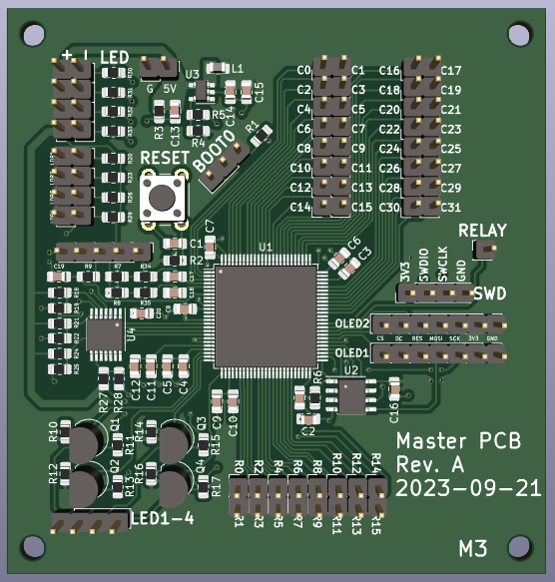

Figure 8: Master PCB render

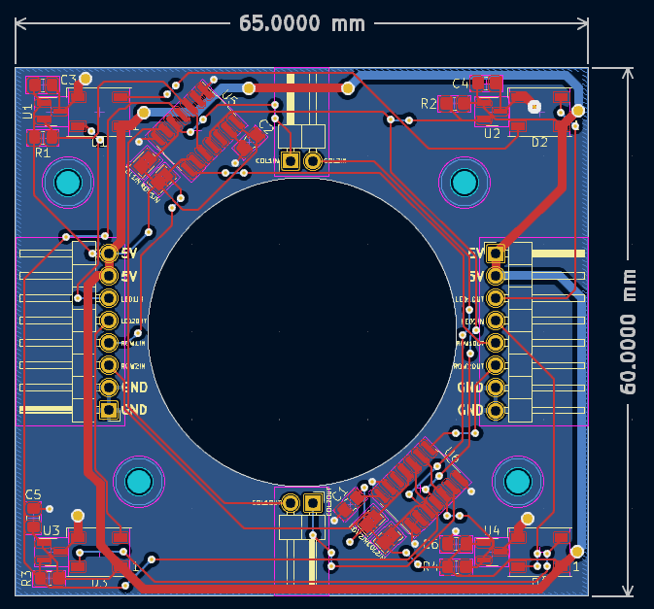

Figure 9: Sensor PCB design

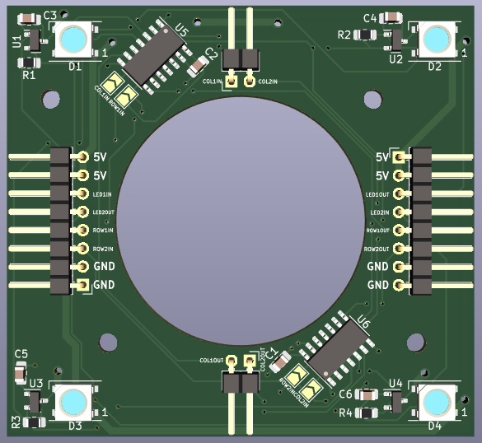

Figure 10: Sensor PCB render